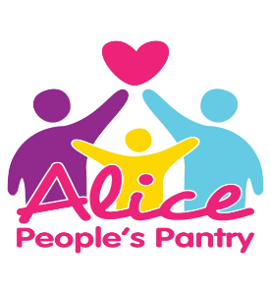
The Assembly Rooms
Merrial Street
Newcastle under Lyme
ST5 2AD
01782614838

People’s Pantry Referral Form
Family Information
Today's Date Reference Number:
Your Name: Date of birth:

Ethnic Origin:
Partners Name: Date of birth:

Ethnic Origin:
Full Address including postcode:

Email:

Contact number(s)
Any Dietary requirements:

Details of children

Full Name | Relationship to child | Age | DOB | Dietary Requirements | School/Nursery attended

Property type: Owned Private rented Housing association

Cooking Facilities (Please tick)
Microwave
Cooker
Slow Cooker
Other

Tea or Coffee
Sanitary items (specify towels/tampons)
Toiletries* (soap, toothpaste)
Nappies *- size
Baby Milk* - brand
Reasons for visit to the pantry

*If available

Do you Require any additional support? (Please tick)
- Family Support-
- Bump and beyond-
- Household items-
- Other – Please state

Please tick to confirm that we can pass on your relevant information to a third party

All the information that we hold on you as a family will be stored securely in a way that is compliant with all GDPR legislation. This information will be stored on our CRM system for 5 years after you have finished accessing our support. All information is stored electronically on the cloud, no paper copies are stored. Information is stored to help our family support team understand your situation better and know how we have supported you previously.
Please tick to confirm that Alice Charity can keep your information on their secure database

Print Name:
Signed:
Date:

Any person over the age of 13 years living within the household will also need to give consent to having their details stored by Alice Charity and give permission for relevant information to be passed onto a third party. By completing the additional adult section below, you are giving us your consent.
Additional Adult Consent:
Name: |  | Sign: |  | Date:
Name: |  | Sign: |  | Date:
Name: |  | Sign: |  | Date:

Pantry Staff Name:
Pantry Staff Date:
Pantry Staff Signature:

